**BA/DA TRAINING**

**Assignment – 9(July17,2019)**

**SHAFALI GUPTA**

1. **Wireframe Examples**

**Ans:-** Awireframe, also known as a page schematic or screen blueprint, is a visual guide that represents the skeletal framework of a website. Wireframes are created for the purpose of arranging elements to best accomplish a particular purpose.

**Groupon App –**

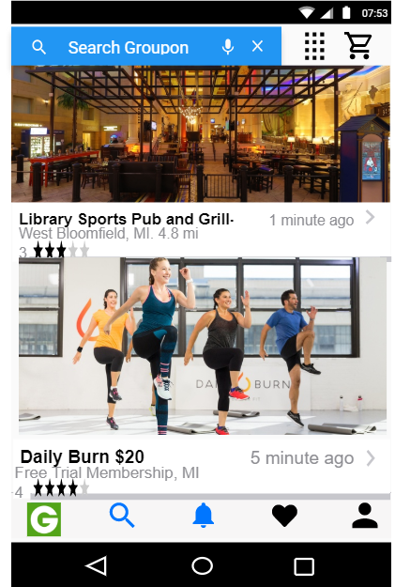

**ATOM Movie Ticket booking App –**

